**Agglomerative Clustering**

Algorithm of Agglomerative clustering.

1. First we compute proximity matrix or similarity matrix : In this it stores similarity or distance b/w two points.
2. Let each data point be a cluster
3. Its repeatative step :

Merge the two closest cluster based on proximity matrix(suppose P2 and P3 are closest).

Update the proximity matrix (now instead of diff. P2 and P3 it have P2 U P3 and we have to calculate distances or similarity of different points from this)

1. Repeat 3 until only a single cluster remains

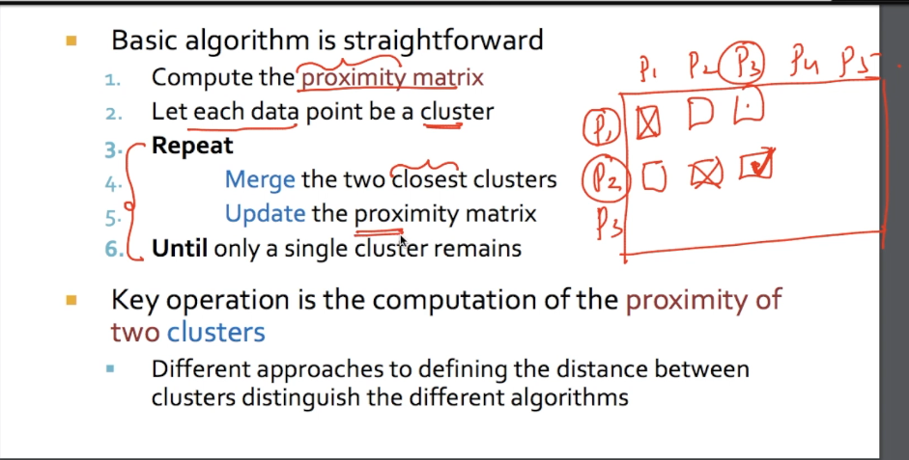

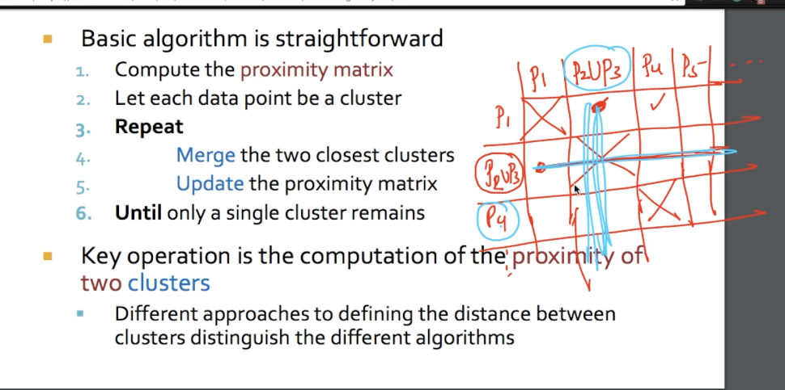

Algorithm is easy only thing is computation of the proximity of two clusters.

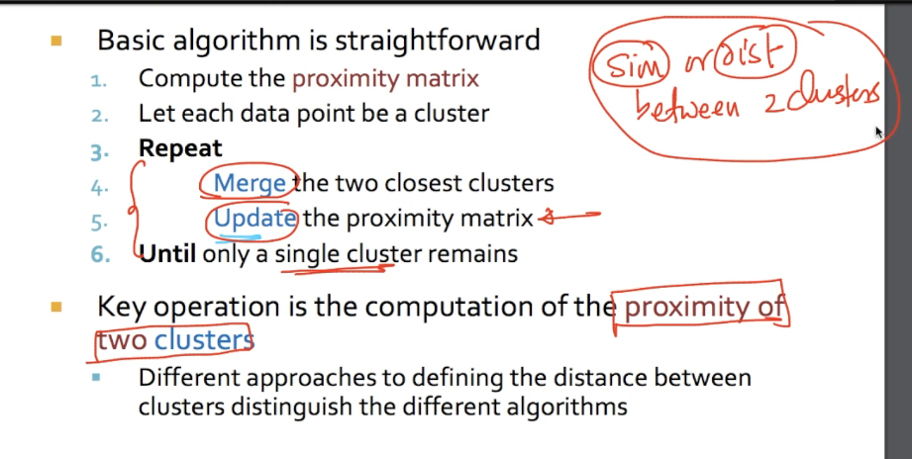

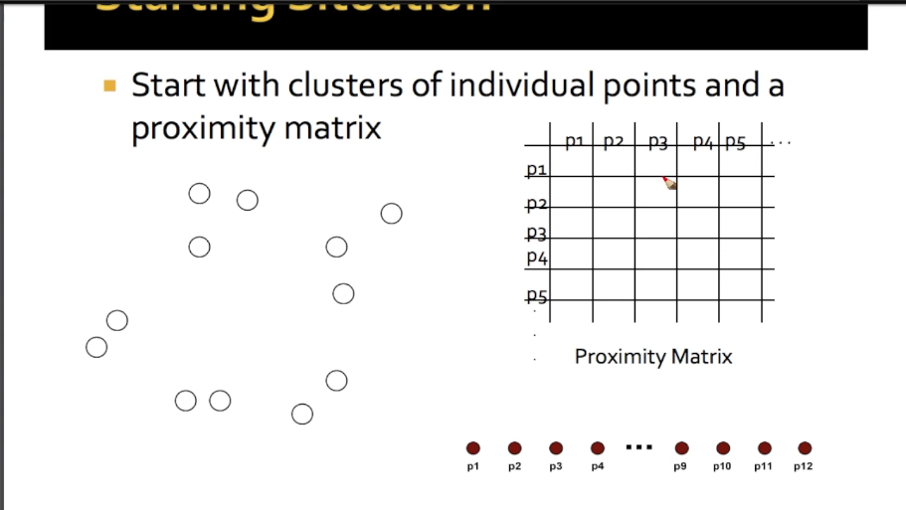

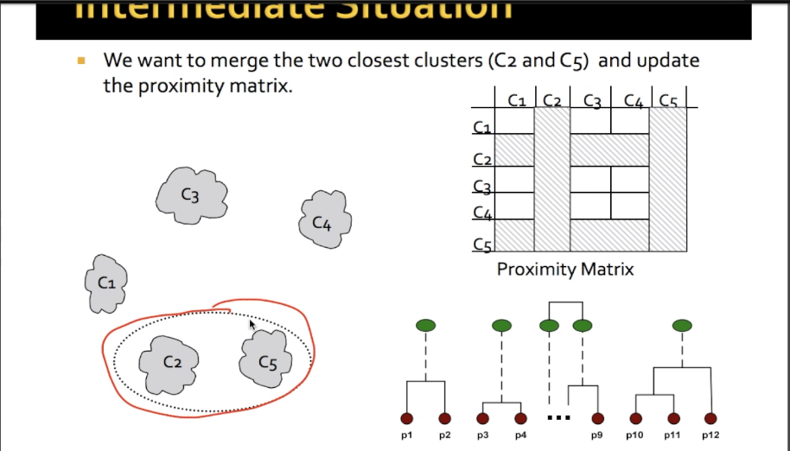

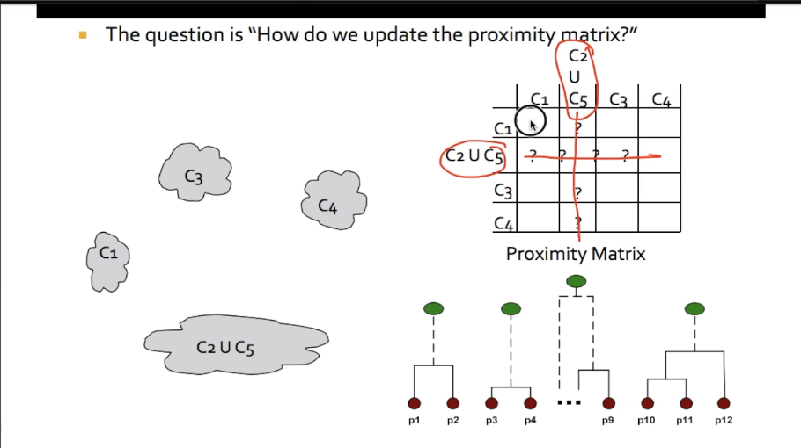

There are various ways to define inter-cluster similarity which is shown in below figure.

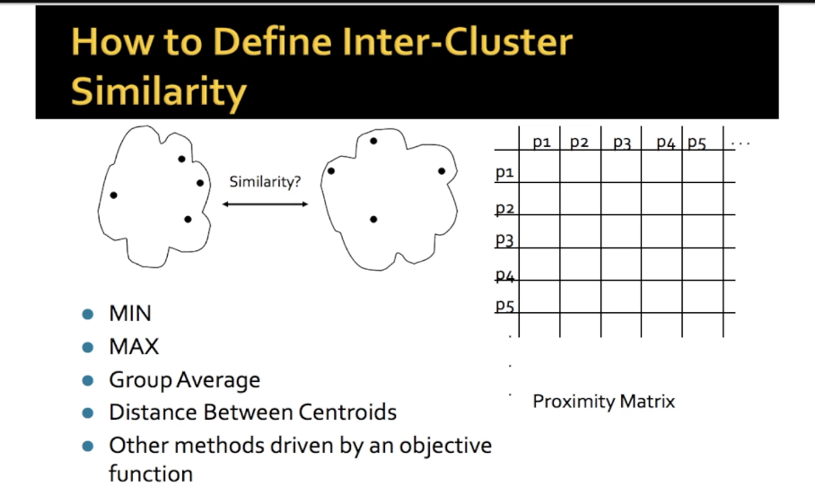

We can code this algorithm just we have to use set union.

